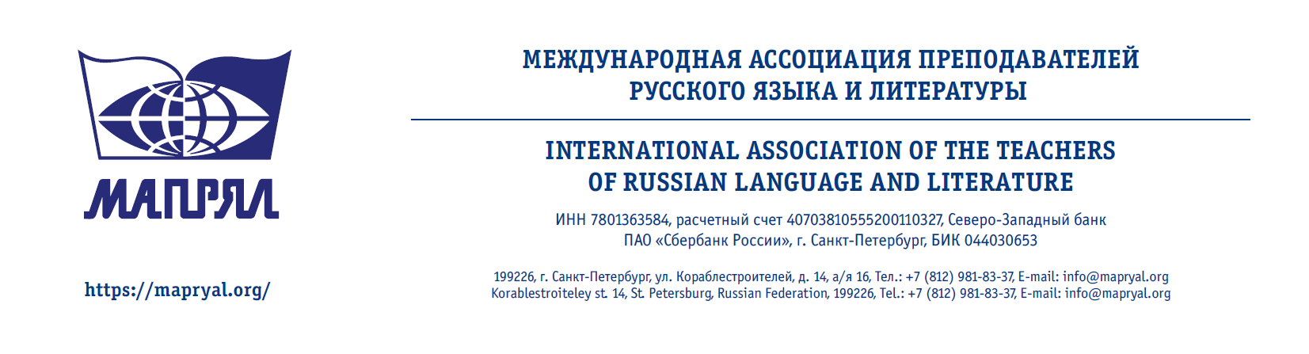

INVOICE

FROM
TO | MAPRYAL
BANK NAME | SWIFT: SABRRU2P  SBERBANK (Severo-Zapadny head office)  St. Petersburg, Russia  BIC 044030653
DOLLAR ACCOUNT NUMBER | 40703840055200210328
EURO ACCOUNT NUMBER | 40703978655200210328
FEDERAL TAX IDENTIFICATION NUMBER | 7801363584
LEGAL ADDRESS | University emb., 11  St.-Petersburg  Russian Federation  199034  DATE

 | Quantity | Fee | Amount
Membership annual fee for 2*** | 1 | 50 $ | 50 $

Office head N.V. Brunova

Chief accountant E.M. Bezginova

